1. **Integration of templates**

[http://doppiaeast.com/article/adding-featured-image-angular-2-wp-theme/](https://apac01.safelinks.protection.outlook.com/?url=http%3A%2F%2Fdoppiaeast.com%2Farticle%2Fadding-featured-image-angular-2-wp-theme%2F&data=02%7C01%7Canishasahu%40virtusa.com%7C03696903ae8a4a26b4ca08d4eea49a2f%7C0d85160c589944caacc8db1501b993b6%7C0%7C0%7C636395838121724152&sdata=HbObCAdwQX8WAqwluI12JsUnmPPmC1nTsmesFU2bTAY%3D&reserved=0)

--> This is related calling a featured image. In the same scenario we called the posts(ref to parent path:

<http://doppiaeast.com/article/angular-2-wordpress-theme-setup/>

<http://doppiaeast.com/article/routing-to-individual-articles/> )

Plugin [https://wordpress.org/plugins/wp-ng/#description](https://apac01.safelinks.protection.outlook.com/?url=https%3A%2F%2Fwordpress.org%2Fplugins%2Fwp-ng%2F%23description&data=02%7C01%7Canishasahu%40virtusa.com%7C03696903ae8a4a26b4ca08d4eea49a2f%7C0d85160c589944caacc8db1501b993b6%7C0%7C0%7C636395838121724152&sdata=bFG5k0W%2Baxm0Pyo3HIfaddxFGRowdIezP0Bqx8YbHQw%3D&reserved=0)

--> As per discussion with radha, the plugin is in Angular1.5.

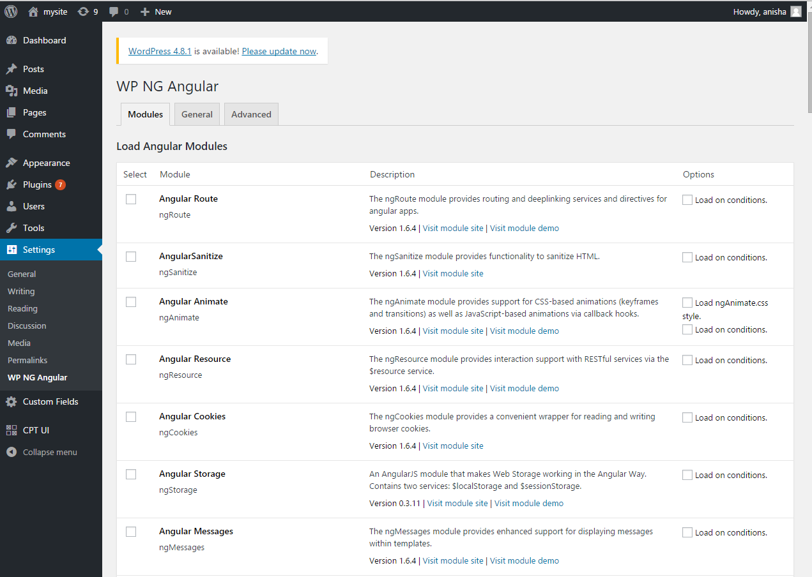

1. **Complete tutorial project Angular 2 with WordPress Integrated…**

[https://github.com/artemdemo/wordpress-restapi-angular2/tree/tutorial](https://apac01.safelinks.protection.outlook.com/?url=https%3A%2F%2Fgithub.com%2Fartemdemo%2Fwordpress-restapi-angular2%2Ftree%2Ftutorial&data=02%7C01%7Canishasahu%40virtusa.com%7C03696903ae8a4a26b4ca08d4eea49a2f%7C0d85160c589944caacc8db1501b993b6%7C0%7C0%7C636395838121724152&sdata=ZXCqdASRMeXp0udDqUDuLgePw%2BAHyJgw9AofJ9d5X1g%3D&reserved=0)

--> In the above github link in index.php file in href they have called to "./app" link but "/app" is not available in the directory.

[https://github.com/stuartkuentzel/ng-wp-theme](https://apac01.safelinks.protection.outlook.com/?url=https%3A%2F%2Fgithub.com%2Fstuartkuentzel%2Fng-wp-theme&data=02%7C01%7Canishasahu%40virtusa.com%7C03696903ae8a4a26b4ca08d4eea49a2f%7C0d85160c589944caacc8db1501b993b6%7C0%7C0%7C636395838121724152&sdata=5GutxdXXwYN4NHtk%2Fi6ihP6rRqUci%2FmYzGJDTUw8HAo%3D&reserved=0)

1. **Dynamically loading stylesheet and js file path in WordPress**

[https://github.com/artemdemo/wordpress-restapi-angular2/blob/tutorial/wp-content/themes/ng-theme/template-app.php](https://apac01.safelinks.protection.outlook.com/?url=https%3A%2F%2Fgithub.com%2Fartemdemo%2Fwordpress-restapi-angular2%2Fblob%2Ftutorial%2Fwp-content%2Fthemes%2Fng-theme%2Ftemplate-app.php&data=02%7C01%7Canishasahu%40virtusa.com%7C03696903ae8a4a26b4ca08d4eea49a2f%7C0d85160c589944caacc8db1501b993b6%7C0%7C0%7C636395838121724152&sdata=T5Ib%2B%2FikBRU5EWsmYEdmoTPd7IdFqGriqQyRomTG%2FNE%3D&reserved=0)

**--> Below is the approach we used to include css and bundle.js file. Some unknown styles.csss file is calling internally here. The files are loaded but the data is not retrieved from the angular app to wordpress frontend.**  
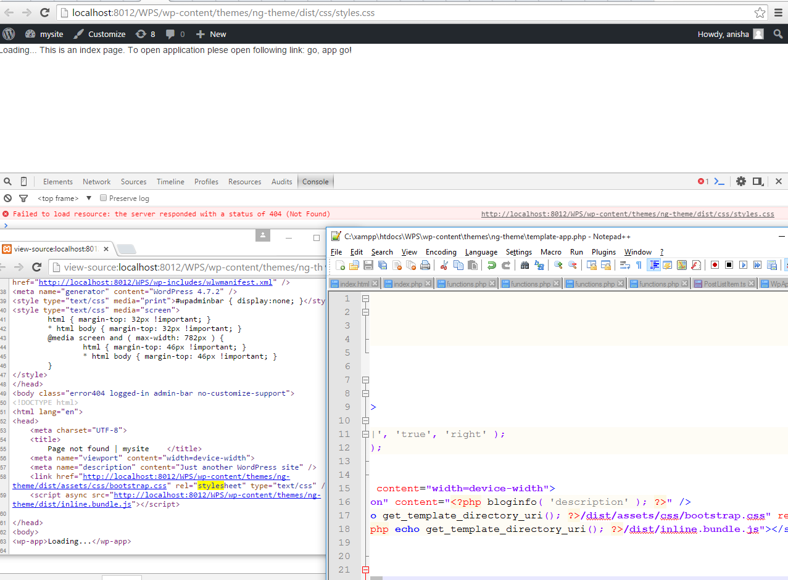

**Our own Approach:**

--> We have written a custom function in main.bundle.js and tried to call it from index.php. It worked. but we failed in calling an existing function of main.bundle.js from index.php as function definitions are inside an anonymous function. We tried to call it in different ways but it did not work.

--> We have created a function "abc( )" in post-list.component.ts file.

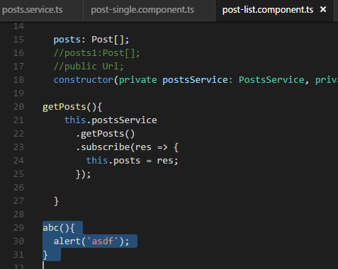

--> After building the above "abc()" , it has converted in the following way.

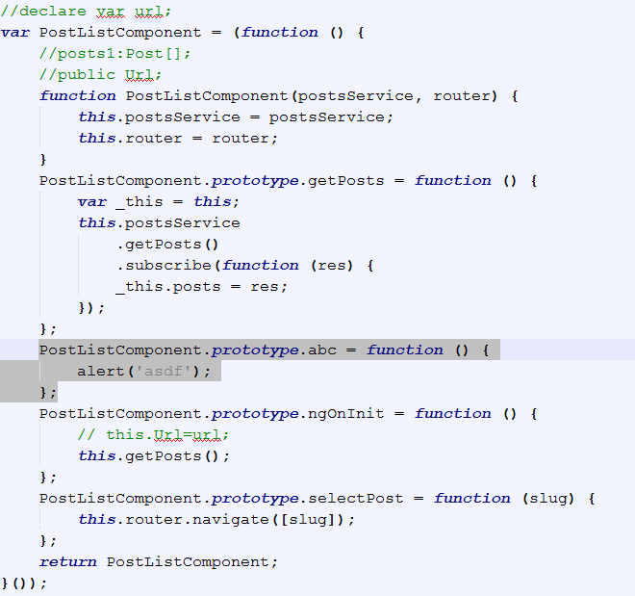

--> We tried calling "abc()" of main.bundle.js in index.php in the following ways.

